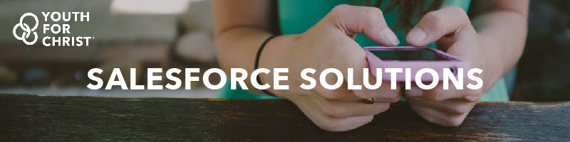

YFC/USA Salesforce Solutions

Salesforce Chapter Master Onboarding Document
https://salesforce.yfc.net
  - Revision 5/03/17

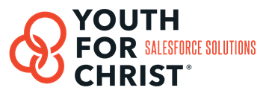

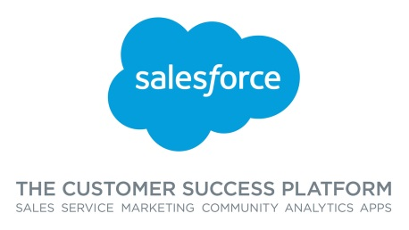

Table of Contents

Getting Started: Expectations 3
Housekeeping: Contract, Payment and Chapter Status 4
Primary Contacts 5
Applying for the Salesforce Foundation Grant 6
Understanding Salesforce 8
How to Prepare your Chapter 9
End Goal: How to set a successful pace for your Chapter? 10

Getting Started: Expectations

From YFC/USA Salesforce Solutions (NSC)
Responsive – Communication is key. Your data is very important and the sooner you can understand it with Salesforce the better. We will move through the necessary steps as quickly as possible, however, we cannot & will not make assumptions about your data.

Continuous Improvement – The Salesforce Base Box is a starting point, however, the sky is the limit with Salesforce. We have an agile development process in place that utilizes a Salesforce Consultant (Fostering LLC) and a group of YFC Chapters and key stakeholders that are constantly looking for ways to improve and/or refine Salesforce for YFC.

Your guide – We are committed to your success. Because of the complexity and importance of doing this well, we will be here to coach you through the migration and training process.

From your Chapter
Responsive – YFC Salesforce can only perform on what you have approved and the expectations you set within your Chapter. The goal is to speak with the appropriate persons (roles) and not make any assumptions about your data. Please respond asap or give an estimated response time when a question is asked, as next steps will be dependent upon it. Have your staff ready and prepared with the information in this packet to ensure a smooth migration and training.

Complete this Packet – Please do not just skim these pages. They will prepare your Chapter for the course ahead. Ask questions and have a goal to understand the process.

Assign an in house Salesforce Administrator – THIS IS REQUIRED. Assign someone at your Chapter who can commit to and has the ability to learn more about Salesforce, be the point person for local questions and submit support requests. If you have questions about who might be a good person for this role, please ask.

Better Together – Creating a community is our goal. Communicating and collaborating with other Chapters will enable us all to use Salesforce better.

Adaptive – Yes, you will have to learn something new. Be prepared and willing. If new technology is not your strong suit, find someone at your Chapter to help you along.

Realistic – The investment is for a long-term successful relationship management platform. You most likely will not raise 10x more money by simply signing up. Long term, if you use this platform to its potential, you will cultivate better donor relationships, increase internal collaboration and that will lead to more donations.

Housekeeping: Contract, Payment and Chapter Status

Contract & Payment
For questions contact:
Diane Phair, YFC Salesforce Solutions Manager
Email: dphair@yfc.net Phone: 303-843-6770

Chapter Project Management
For your Chapter’s migration status, please go to the YFC/USA Salesforce website: http://salesforce.yfc.net/home/ Click on Chapter Implementation and then Chapter Implementation Status. Then click on your Chapter’s tab on the excel worksheet.

Setting your Chapter’s timeline
Step 1) Assign the right people in the right roles. In Salesforce, assign the following roles to your staff.
- System Admin & Data Processor
- Executive/Development/Marketing
- Program Staff

Step 2) Work with YFC/USA and Fostering LLC to plan the project timeline:
 | Step | Responsible | Estimated Time
1 | YFC Contract signed, Schedule Conversion Date, Salesforce Grant and application, YFC Salesforce NSC Kick Off Meeting with ED | YFC/USA, Chapter, Fostering LLC | 1 Week
2 | Clean up your existing data | Chapter & Fostering LLC | 1-3 Week(s)
3 | Mapping Legacy data to Salesforce Fields | Chapter & Fostering LLC | 1 Week
4 | Export Data from Legacy System | Fostering LLC | 2-3 Days
5 | Import Data to Salesforce and Run Tests | Fostering LLC | 1 Week
6 | Spot Check your data in Salesforce – Sign off | Chapter | 1-2 Days
7 | Salesforce 101 Live Training* | YFC/USA & Chapter | 2 Days
 | Total average timeline: 3-6 weeks

Primary Contacts

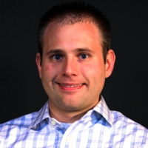
Sean Wallinger
Contact for: Contract and Chapter scheduling
NSC Manager and overall project success lead
swallinger@yfc.net
303-843-6763
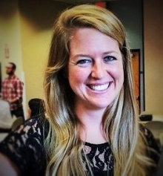
Diane Michaelis
Contact for: Overall Salesforce Project Management and Training
YFC Salesforce Solutions Manager
DMichaelis@yfc.net
303-843-6770
Matt Foster
Contact for: Data Migration into Salesforce and Technical Support
Owner of Fostering LLC, Salesforce Consulting & Development Partner
Matt@fosteringllc.com
320-245-7955

The YFC Salesforce HOA (Home Owners Association)

The role of the HOA is to refine, develop and improve the YFC Base Box. Please provide your feedback and ideas for Salesforce via the online ticket system or email dphair@yfc.net.

2017 HOA Members Include:
Sean Wallinger, Associate VP Controller, YFC USA
Matt Foster, Owner of Fostering LLC
Diane Michaelis, Salesforce Solutions Manager, YFC USA
Matt Schulte, Executive Director, Lincoln Area YFC

Applying for the Salesforce Foundation Grant
Steps to Complete the Salesforce Grant Process
Note: This is a mandatory/required process before any work can be done on your Salesforce organization. You should be able to get this all done within 30min to 1 hour.

Step 1: Start a Free 30-Day trial of Salesforce
- Go to: http://www.salesforce.org/start-trial/
- Click the “Free 30-Day Trial” Download button.
- Click the green “Free Trial” Button
- Fill out the requested information completely – use your email address as your username and click the box that says, “I agree to the Master Subscription Agreement.”
- Fill out the requested information and click the box that says, “I agree to the Master Subscription Agreement.”
- Click the “Submit” button.
- You will receive an email from Salesforce with your Free-trial confirmation. In this email click the link “To log in now, click…”
- After you click the link you will be prompted to create a password. Please use crmhelp1234. (You can change this later)
- After you complete this please email matt@fosteringllc.com your username and password.
- After Fostering LLC receives your login information you will receive another verification email from Salesforce with a 6-digit confirmation code. Please email this to matt@fosteringllc.com as well.

Step 2: Apply for the Salesforce Foundation Grant
- Go to http://www.salesforcefoundation.org/power-of-us/
- Read through the “Power of Us Program Overview” and watch the overview video.
- Click on the “Apply Now” button.
- Click on the “Log in To Apply” link.
- Enter you login credentials (if prompted) and/or Click “Allow” when the Power of Us Hub requests permission to access your basic Salesforce information.
- You will be promoted to take a simple Readiness survey. Please answer the questions in this way:

- Implementation Vision and Plan (Absolutely)
- Strong Executive Sponsorship (Absolutely)
- Internal Salesforce Aptitude (Absolutely)
- Commitment to Continued Learning (Absolutely)
- Implementation Resources (Absolutely)
  - Who is your consulting partner or skilled resource? (Fostering, LLC)
- Data Migration and Integrity (Absolutely)
  - (Submit)
- Step 3: Fill out the contact and Chapter information as requested.
- Step 4: You will be requested to enter Your Chapter EIN and charity ID number, you can look these up by clicking here: http://nccsweb.urban.org/PubApps/search.php/
Feel free to use this wording for the following questions:
Please describe your organization’s mission (500 words or less).
YFC reaches young people everywhere, working together with the local church and other likeminded partners to raise up lifelong followers of Jesus who lead by their Godliness in lifestyle, devotion to the work of God and prayer, passion for sharing the love of Christ and commitment to social involvement.
How do you see salesforce.com helping further this mission?
Our local Chapter and National Headquarters has done extensive research and prepared time and resources to effectively implement Salesforce.com for our organization.

We see Salesforce giving us capacity to:
- engage our constituents in a higher relationship based methodology with access anywhere and the SF1 mobile application
- increase of efficiency to communicate with our volunteers and constituents
- ability to advance with the robust 3rd party app exchange.
All of this equals more efficient and effective means to deliver a higher value to those we serve and those who serve alongside us. Investing in our kids today to impact tomorrow.

- Step 5: Upload documentation of your Chapter EIN as well as the NSC blanket 501c3 document (see attached.) We have established a group approval for the YFC network so there should be no challenges with obtaining approval.
- When the application has been completed, simply “Submit” as directed.
- Within 2-5 business days you will receive an email from Salesforce with confirmation of your Salesforce Foundation Grant approval.
- Please forward this email to matt@fosteringllc.com. This will trigger the process of uploading your YFC Base Box to your Salesforce organization.

If you require additional assistance:
Salesforce Grant Process
Email: crmdonation@salesforce.com
Phone: 1-800-NO-SOFTWARE | 1-800-667-6389

Understanding Salesforce

Overview

Salesforce.com is a large company, the largest CRM Company in the industry. Here are a few reasons why:
  - 100% Cloud based (never have to load anything on your computer or server)
  - Over 2,500 3rd party integrated applications
  - Great resources for your Chapter from Salesforce:
    - Power of Us HUB – Salesforce Non-Profit community https://powerofus.force.com
  - The beauty of Salesforce is that it is the best tool in the industry and because of their philanthropy model, each YFC Chapter has been granted 10 free user licenses.

YFC Base Box
Salesforce is a robust and widely customizable platform, please watch this video to give a preview of how we have customized Salesforce for YFC.
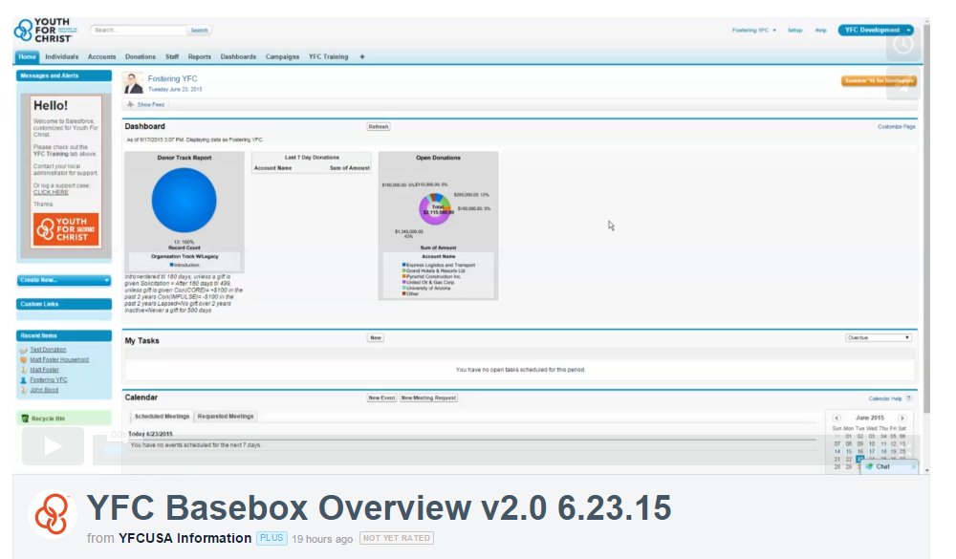

https://vimeo.com/131684670

This is a high level overview, please do not feel the need to fully understand everything, we have a training model and are creating self-paced learning options as well.
Please preview this mapping document to visualize how your existing data will show up in Salesforce: https://salesforce.yfc.net/uploads/default/YFC_USA_Basebox_Salesforce_Mapping3.20.15.pdf

How to Prepare Your Chapter for Salesforce

- Understand the process: We have provided a shared project management spreadsheet. Please go to: http://salesforce.yfc.net/home/ Click on the Chapter Implementation tab and then Chapter Implementation Status on the left. Then click on your Chapter’s tab on the excel worksheet.

- Getting your team ready: The #1 priority is to get your data process (gift entry) person familiar with Salesforce first. Please have the donations processor and business admin go to: https://salesforce.yfc.net/training_page/training_videos_by_role/ and the videos. This should be done prior to you Salesforce Training call.

- Helping us configure your Salesforce: In order for Fostering LLC to configure your Base Box to your needs, please complete the local configuration document, found here: http://salesforce.yfc.net/training_page/documentation_templates/ and click on the “Chapter Configuration Worksheet”. Return this document to matt@fosteringllc.com and dmichaelis@yfc.net.

- To prepare for your data conversion: Please review this mapping document to better understand Salesforce and where your data should go: https://salesforce.yfc.net/uploads/default/YFC_Fundraising_Structure_of_Salesforce_Fund_Mapping6.23.15.pdf

- Get ready to spot check/review your data: After Fostering LLC has migrated your data you will be provided a YFC Migration Summary. You will be asked to sign-off that the conversion process was done correctly. Please check over donors and donations.

- Training: Salesforce 101 Training will take place the week after you sign off on your data. Again, the more training videos you watch the better training will go.

- On-Going Support: We have an active case management system in place to help answer questions, make changes and suggest improvements. This is where you can submit technical questions as you begin to use Salesforce.

End Goal: How to set a successful pace for your Chapter?
The primary metric for measuring success is two-fold.

- Are you using Salesforce?

- Are your users logging in frequently (a minimum of 4-5 times per week)
- Are the right people doing the right things in Salesforce?
- Are you collaborating on important relationships?

- Adopting the Agile process. Customer Relationships are never “done” and you should always be thinking of creative ways to use Salesforce to your advantage. This diagram describes the continual cycle of improvement that successful Salesforce users will adopt. It’s a way of thinking that needs to be adopted.
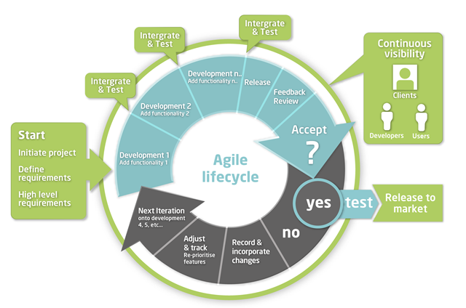

Please note, this is what YFC/USA and the HOA is doing every week. We get together on a conference call to discuss, develop, refine, test and deploy new solutions all the time with Salesforce.

Please subscribe to our newsletter to receive the latest updates: http://yfc.us10.list-manage.com/subscribe?u=050b369525d6bfc1e199d3927&id=cd42cd2e8b

